**ADE7912, ADE7913, ADE7932, ADE7933 Data Sheet Detailed Change List**

Parameter specification changes are listed as follows:

1. ADC Offset Drift Over Temperature   
     
   From: -500 PPM/°C minimum, +500 PPM/°C maximum for V1 channel only  
     
   To: +200 PPM/°C typical for V1 channel only
2. Gain Drift Over Temperature   
     
   From: -135 PPM/°C minimum, +135 PPM/°C maximum for current channel  
    -65 PPM/°C minimum, +65 PPM/°C maximum for V1 and V2 channel

To: -135 PPM/°C minimum, +135 PPM/°C maximum for current channel  
 -85 PPM/°C minimum, +85 PPM/°C maximum for V1 and V2 channel

1. Input Current, Iin

From: 15 nA maximum

To: 0.015 uA typical, 1uA maximum

This product has achieved UL, CSA and VDE certification and absolute maximum rating changes are listed as follows:

1. Regulatory Approvals  
   From:

|  |  |  |
| --- | --- | --- |
| UL | CSA | VDE |
| Recognized Under UL 1577 Component Recognition Program | Approved under CSA Component Acceptance Notice 5A | Certified according to DIN V VDE 0884-10 (VDE V 0884-10):2006-12 |
| Single Protection, 5000 V rms Isolation Voltage | Basic insulation per IEC 61010-1, 400 V rms (564 V peak) maximum working voltage | Reinforced insulation, 846 V peak |

Note: In accordance with UL 1577, each ADE7912/ADE7913 is proof tested by applying an insulation test voltage ≥ 6000 V rms for 1 second (current leakage detection limit = 10 μA).   
  
To:

|  |  |  |
| --- | --- | --- |
| UL | CSA | VDE |
| Recognized Under UL 1577 Component Recognition Program | Approved under CSA Component Acceptance Notice 5A | Certified according to DIN VDE V 0884-10 (VDE V 0884-10):2006-12 |
| Single Protection, 5000 V rms Isolation Voltage | Basic insulation per CSA 60950-1-07+A1+A2 and IEC 60950-1 2nd Ed.+A1+A2:   * 830 V rms (1173 V peak) maximum working voltage   Basic insulation per CSA 61010-1-12 and IEC 61010-1 3rd Ed. (pollution degree 2, material group III, overvoltage category II, III and IV):   * 300 V rms (424 V peak) maximum working voltage.   Reinforced insulation per CSA 60950-1-07+A1+A2 and IEC 60950-1 2nd Ed.+A1+A2:   * 415 V rms (586 V peak) maximum working voltage   Reinforced insulation per CSA 61010-1-12 and IEC 61010-1 3rd Ed. (pollution degree 2, material group III, overvoltage category II, and III):   * 300 V rms (424 V peak) maximum working voltage. | Reinforced insulation, 846 V peak |
| FILE E214100 | FILE 2758945 | FILE 2471900-4880-0001 |

In accordance with UL 1577, each ADE7912/ADE7913 is proof tested by applying an insulation test voltage ≥ 6000 V rms for 1 second (current leakage detection limit = 15 μA).

1. Critical Safety Related Dimensions and Material Properties  
   From:

|  |  |  |  |  |
| --- | --- | --- | --- | --- |
| Parameter | Symbol | Value | Unit | Test Conditions/Comments |
| Tracking Resistance (Comparative Tracking Index) | CTI | >600 | V | IEC 60112 |

To:

|  |  |  |  |  |
| --- | --- | --- | --- | --- |
| Parameter | Symbol | Value | Unit | Test Conditions/Comments |
| Tracking Resistance (Comparative Tracking Index) | CTI | 400 | V | IEC 60112 |

1. VDE Characteristics  
   From:

| Description | Test Conditions/Comments | Symbol | Characteristic | Unit |
| --- | --- | --- | --- | --- |
| Climatic Classification |  |  | 40/105/21 |  |
| Surge Isolation Voltage | VPEAK = 10 kV, 1.2 µs rise time, 50 µs, 50% fall time | VIOSM | 6000 | V peak |

To:

| Description | Test Conditions/Comments | Symbol | Characteristic | Unit |
| --- | --- | --- | --- | --- |
| Climatic Classification |  |  | 40/085/21 |  |
| Surge Isolation Voltage | VPEAK = 10 kV, 1.2 µs rise time, 50 µs, 50% fall time | VIOSM | 6250 | V peak |

1. Thermal Derating Curve  
   From:

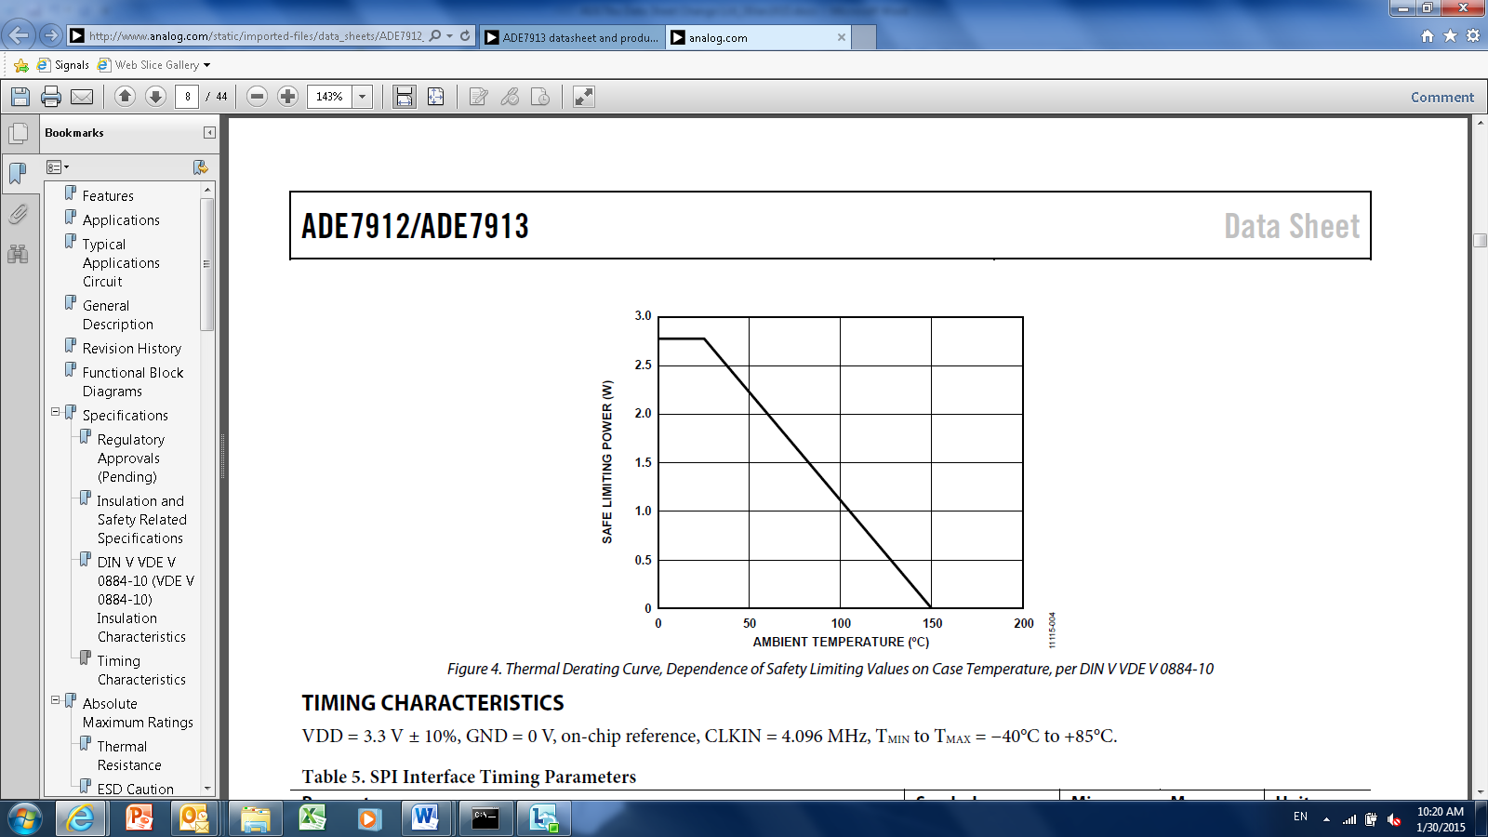

To:

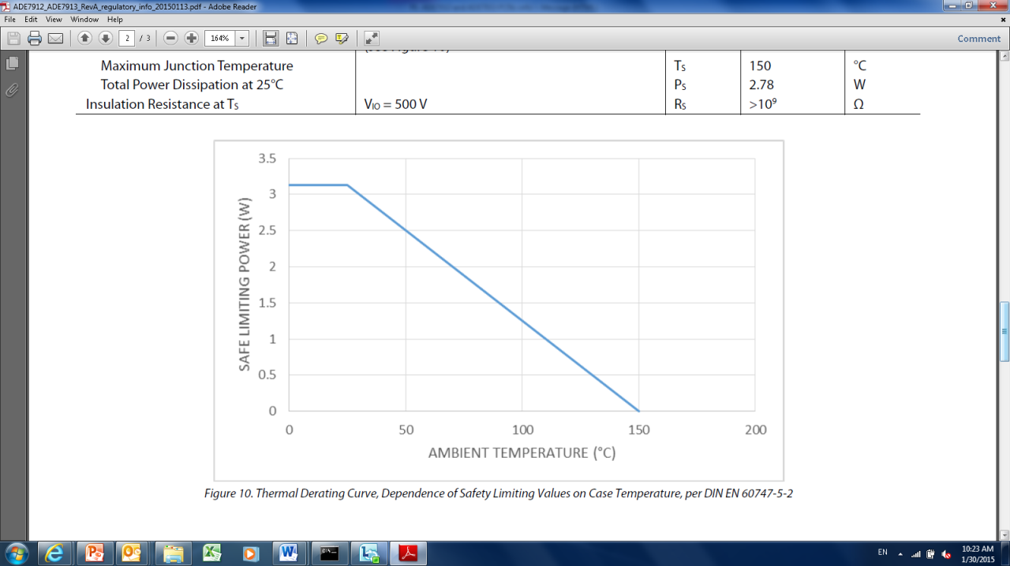

5. Maximum Continuous Working Voltage Supporting a 50-Year Minimum Lifetime   
  
 From: AC Voltage, Bipolar Waveform 564V peak  
 DC Voltage, Basic Information 600V peak  
  
 To: AC Voltage, Bipolar Waveform 400Vrms  
 DC Voltage, Basic Information 1173V peak